* Scala is a JVM language. Ie , it works on JVM
* It gives us functional styling
* Ie, not just object oriented, we can write code in functional style as well.

Creating a scala worksheet:

Before saving:

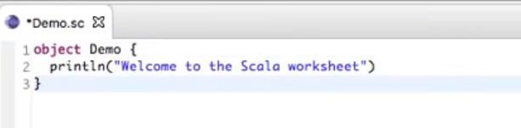

After saving:

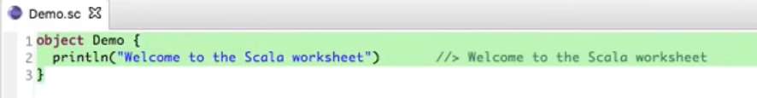

* Scala provides you something called as REPL.

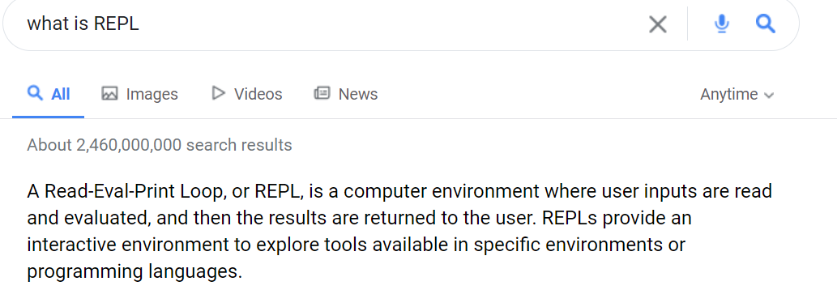

* We can use Scala Interpreter as well for achieving this REPL.

Below are some examples of using scala interpreter for achieving REPL.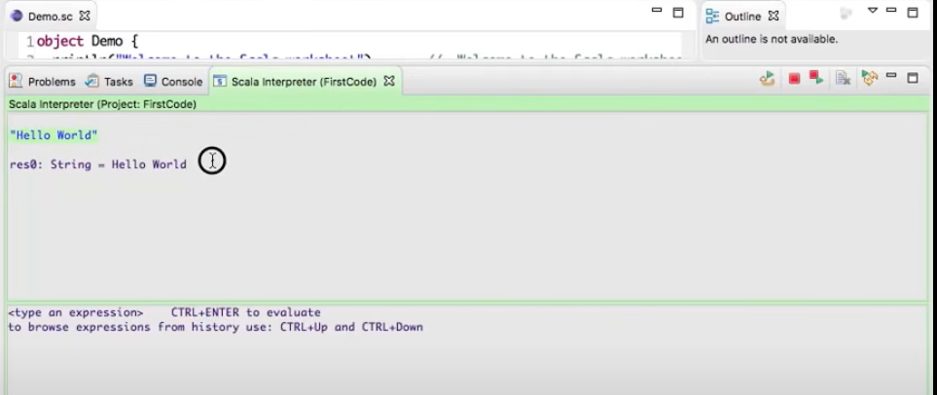

Defining variable in Scala:

* var i = 9
* var num : int =9 // in scala variable name is more important than type.

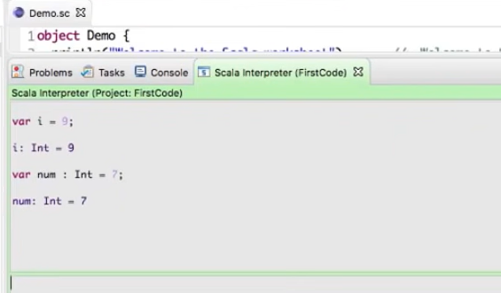

* Adding 2 numbers

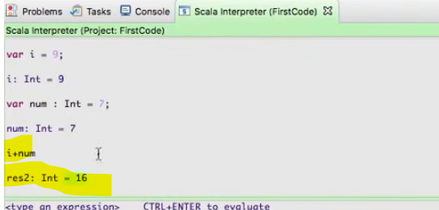

* For defining strings we have similarly other ways:

Var name=”Hareesh”

Or

Var name: String-“Hareesh”

**Writing Code in Worksheet**

Note: In scala everything is a class. Every data type is class. There is no primitive data type in scala just like in Java.

* In scala we don’t need semi colon to differentiate each lines.

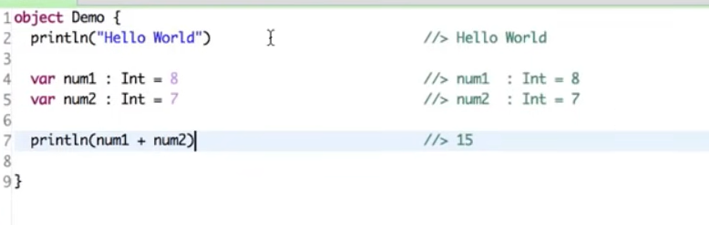

* Can we change values of variables in Scala? Yes we can do that.

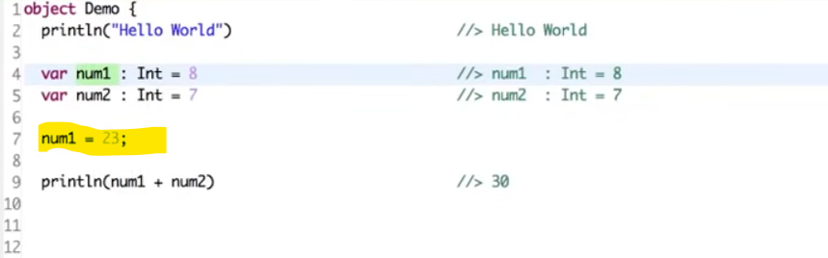

* But scala believes that there should not be any mutation.ie, changing the value of a variable is called mutation. And we should not do mutation. Scala believes in concurrency.ie, if multiple threads are working on the same variable then we should not change the value of that variable.
* In Java by using final key word we can stop value change.
* In scala only way to do that is by using **val** keyword.Once we create a variable using val, it becomes a constant.

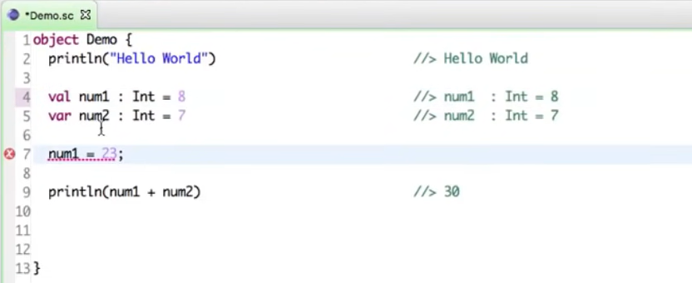

* See below operation.

Var result= 8 + 7

Here + is an operator. But as per scala everything is an Object and a method.

* **def** is the way to define a method in scala.

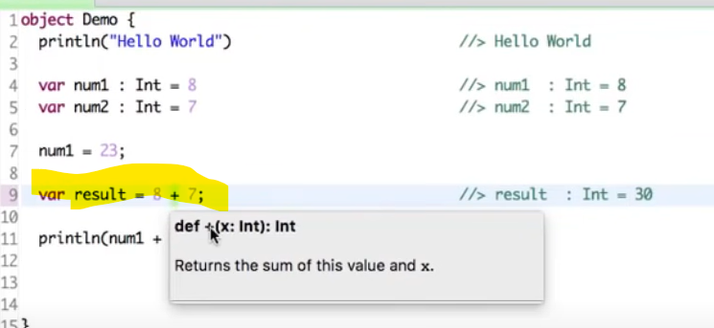

Here **+** is not an Operator , it is a function.

**8+ 7 => 8 . +(7)**

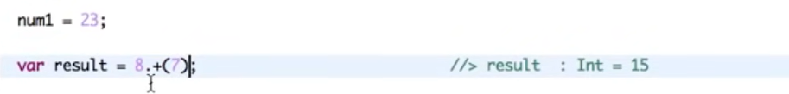

**Class and Object In Scala**

**Creating Java Class:**

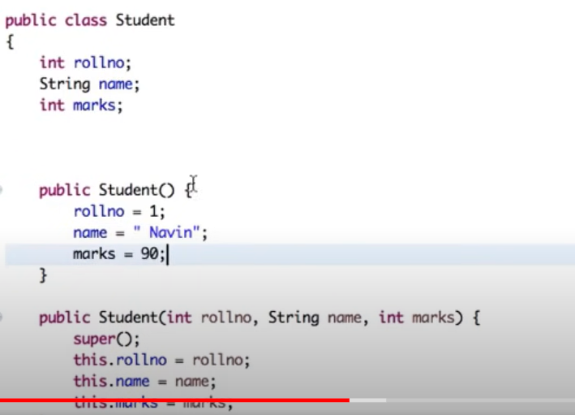

**Creating Class and Object in Scala:**

* In order to create class in scala we use a special keyword called **case**
* We can mention the constructors while creating class itself in brackets

**Class**:

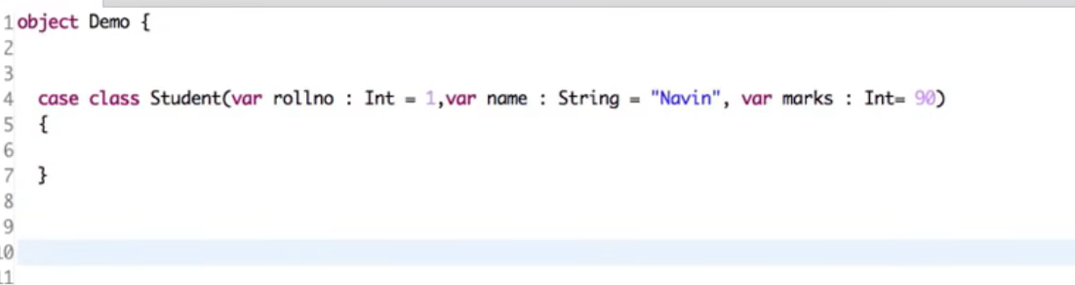

**Object of Student Class**:









* Note: In java we need to create multiple overloaded constructors but in scala its not needed.

**Creating Methods in Scala**:

* Using **def** keyword
* We will use a = operator while defining a method.
* If we have more than 1 line then we use curly brackets.
* We can call the method using the dot (.) operator

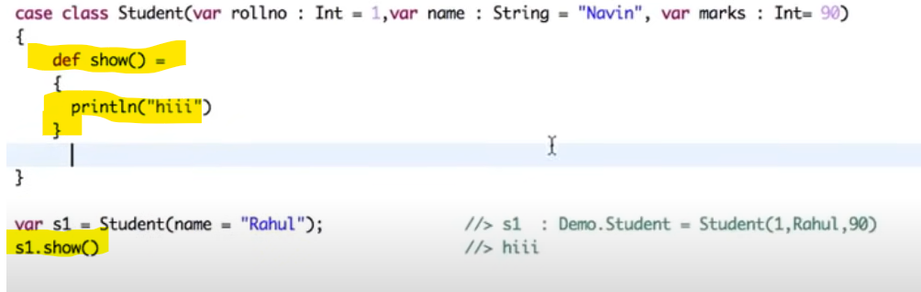

**Comparing two objects in scala**:

Eg:

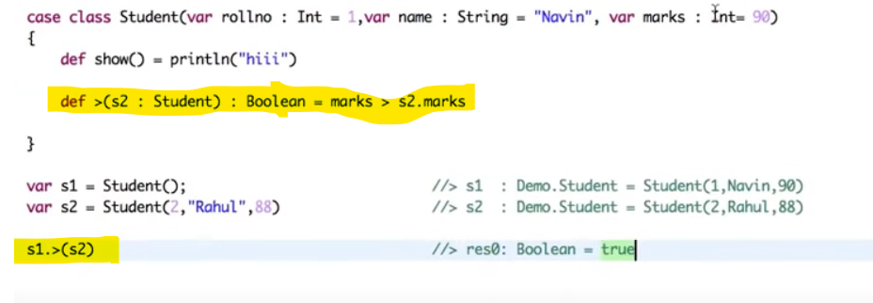

**List and Lambda Expressions in Scala**:

List in Java:

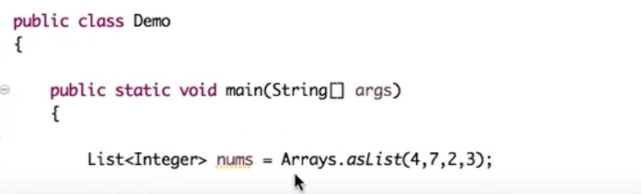

List in Scala:

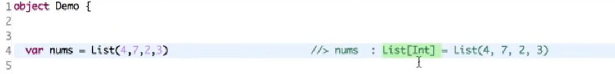

Printing List in java using enhanced for Loop:

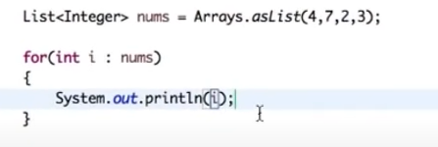

Printing List in scala using enhanced for Loop:

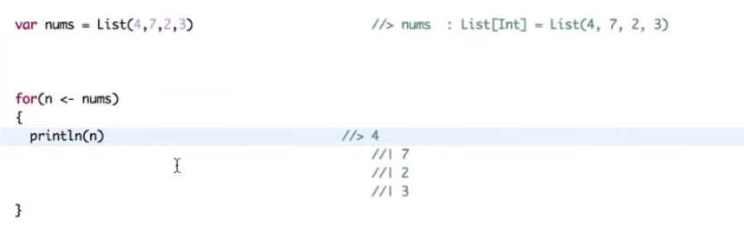

Note: In java we use a colon in enhanced for loop, but in scala we use a left arrow.

Using Lambda in java:

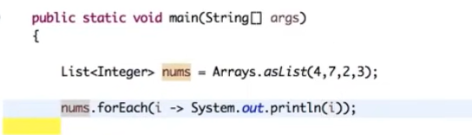

Using Lambda in scala:

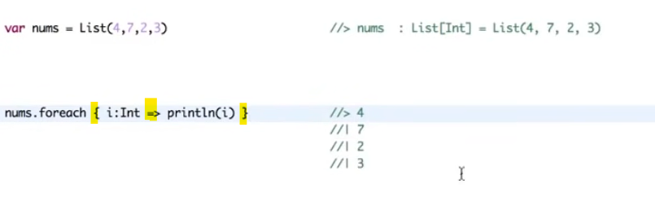

Note:

* We need to use curly braces for forEach in scala.
* We need to use double arrow as lambda operator in scala.